IBM Machine Learning Professional Certificate | Unsupervised Machine Learning - Final Project
Customer Segmentation
Five customer segments that show where churn and revenue risk sit
A stakeholder report that compares five unsupervised learning variations - clustering algorithms, feature sets and PCA-based dimensionality reduction - on IBM's Telco Customer Churn data, recommends one segmentation and turns it into segment-specific actions.
5  customer segments, stable across resamples (adjusted Rand index 0.99) | 65%  of the revenue lost to churn comes from one segment holding 27% of customers | 1%-56%  churn rate range across segments, although churn was not used to build them

Prepared for | Chief Data Officer and Head of Analytics
Prepared by | Omar Essam, Data Scientist
Date | October 24, 2026
Analysis behind this report | Final Project/Unsupervised ML - Customer Segmentation.ipynb

Contents
Executive summary 2
1. Main objective of the analysis 3
2. Data description 3
3. Data exploration and preparation 4
4. Model variations 4
5. Final model recommendation 6
6. Key findings and insights 7
7. Do segment-specific churn models beat one global model? 8
8. Limitations of the model 8
9. Next steps 9
Appendix: method and reproducibility 10

Executive summary
The 7,043 customers of the provider were grouped by how they behave - how long they have stayed, how committed they are, what they buy and what they pay - using clustering. Five model variations were compared; K-means with 5 clusters on six engineered behavioural features gives the clearest, most stable and most actionable segmentation.
Key insights
- Fiber newcomers are the problem segment. 27% of customers, but 56% of them churn and they account for 65% of the monthly revenue lost to churn: new (17 months on average), almost all month-to-month, fiber, $85 a month with few protection add-ons, and 61% pay by electronic check.
- Commitment and bundles separate loyal from at-risk customers. The three long-tenure segments (Premium fiber loyalists, Loyal DSL bundlers, Phone-only veterans) churn at 1%-19% and carry multi-year contracts or rich service bundles.
- Not all newcomers are equal. Budget newcomers are just as new (12 months) but spend less ($39) and churn at 26%, half the rate of Fiber newcomers - their risk is cheaper to manage.
- The most valuable customers are not the riskiest. Premium fiber loyalists pay the most ($103) and bring 27% of revenue with 19% churn.
- Segments guide strategy, not prediction. Churn models trained per segment do not beat one global model (test ROC AUC 0.843 vs 0.843); the value of the segmentation lies in targeting and communication.
Recommendation
- Adopt the K-means segmentation (k = 5) on the six behavioural features - best on every quality metric (silhouette 0.37, Davies-Bouldin 1.06), stable (adjusted Rand index 0.99), simple to explain through segment averages and easy to apply to new customers.
- Run one playbook per segment: concentrate retention budget on Fiber newcomers, onboard Budget newcomers cheaply, protect Premium fiber loyalists, and cross-sell to the low-churn segments.

1. Main objective of the analysis
The objective is to segment the customer base with clustering so that marketing, retention and product teams can treat different kinds of customers differently. The analysis focuses on clustering; dimensionality reduction (PCA) supports it, to compress the raw service flags and to map the segments in two dimensions. The segmentation should group customers who behave alike, be stable enough to use month after month, and be easy to describe in business language.
The benefits for the business are:
- Focused retention spend: know which group produces most of the churned revenue and act there first.
- Segment-specific offers: onboarding, upgrades, bundles and loyalty rewards matched to each group's needs.
- A shared language: a handful of named segments that finance, marketing and customer care can all track over time.
- Better analytics downstream: segments can be added to dashboards and tested as inputs to predictive models (section 7).

2. Data description
The data is IBM's Telco Customer Churn sample dataset: one record for each of 7,043 customers of a fictional telecom provider, with 19 attributes and a churn flag (26.5% of customers left in the last month). It was chosen because customer segmentation is a common, high-value business question and the same data was used for the churn classification project, so segments and churn drivers can be compared.
Group | Attributes | Type | Role in this analysis
Relationship | tenure (months, 0-72), Contract (month-to-month, one year, two year) | Numeric / categorical | Clustering inputs (contract converted to months)
Services | InternetService (DSL, fiber, none), PhoneService, MultipleLines, 4 protection add-ons, 2 streaming services | Binary / categorical | Clustering inputs (fiber flag and add-on counts)
Charges | MonthlyCharges, TotalCharges | Numeric | MonthlyCharges is a clustering input; TotalCharges is dropped (tenure x monthly)
Billing | PaperlessBilling, PaymentMethod (4 methods) | Categorical | Used to describe segments, not to build them
Household | gender, SeniorCitizen, Partner, Dependents | Binary | Used to describe segments, not to build them
Outcome | Churn (Yes / No) | Binary | Never used to build segments; used to judge their business value

The analysis aims to find a small number of behaviour-based customer groups that differ clearly in loyalty and value, so that each can receive its own strategy.

3. Data exploration and preparation

Exploration and cleaning
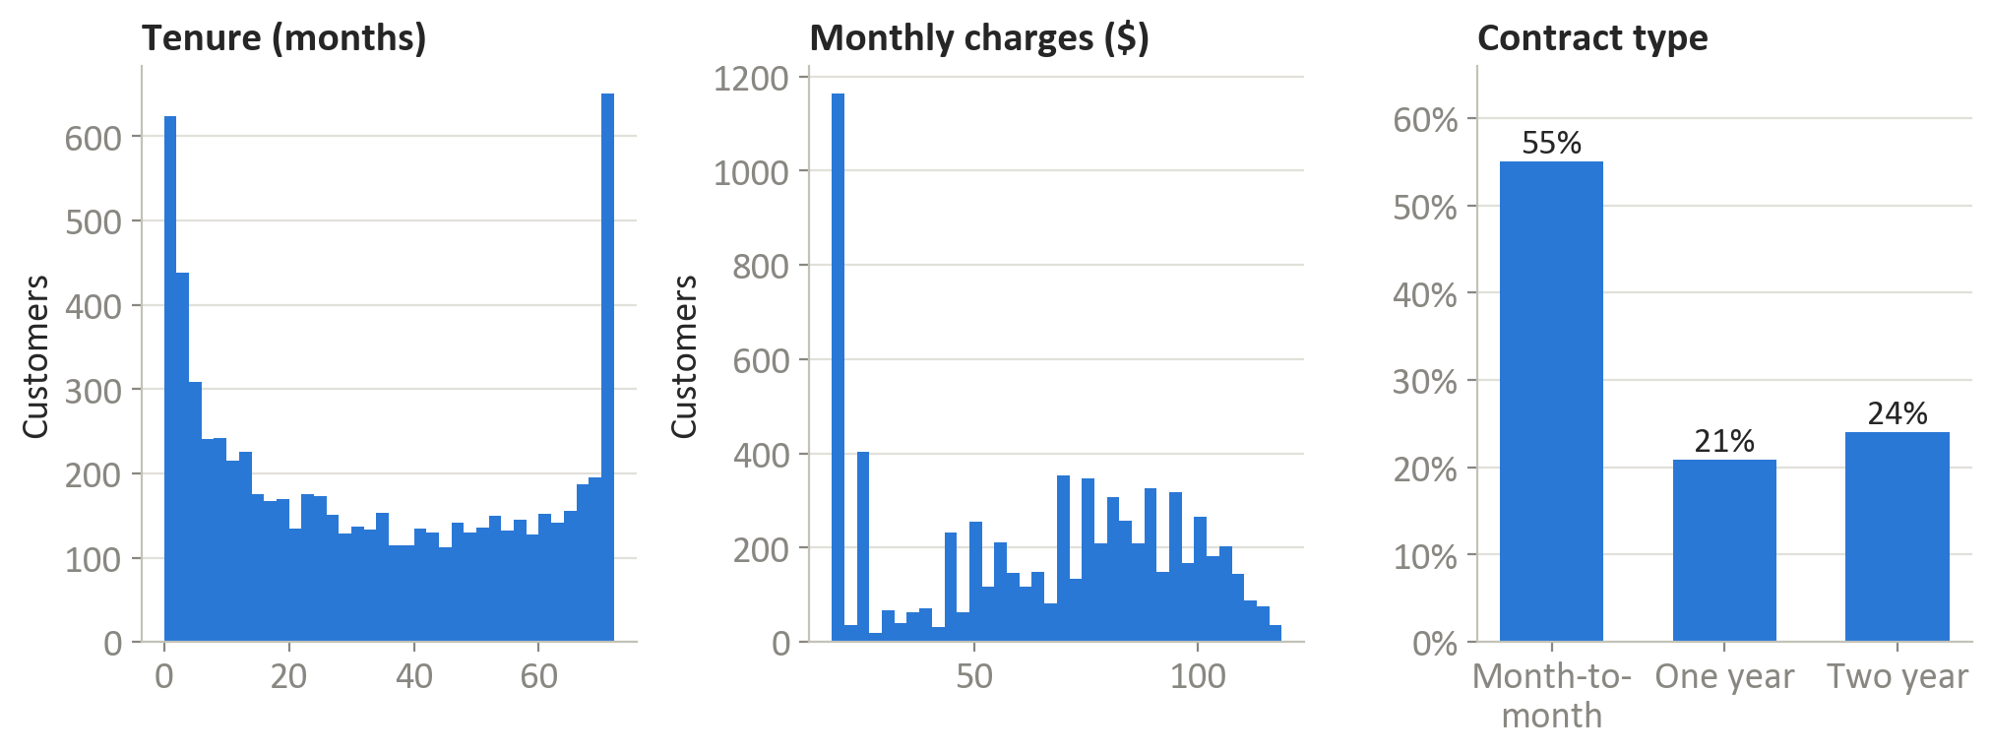
Figure 1 - Tenure is U-shaped (many new and many very long-standing customers), monthly charges are multi-modal, and more than half of the customers are on month-to-month contracts.
- TotalCharges was stored as text; its 11 blanks belong to brand-new customers (tenure 0) and were set to 0. There are no duplicates and no other missing values.
- The distributions are lumpy rather than bell-shaped - a first sign that the customer base is made of distinct groups.
- Relationship and spend variables are correlated (tenure vs contract length r = 0.67; monthly charges vs fiber r = 0.79), which PCA summarises well.

Feature engineering: two candidate feature sets
Feature set | Features | Why
Raw service profile (18) | tenure, contract months, every internet, phone, add-on, billing, payment and household flag | Uses all the information; clustered on its first 10 principal components (81% of the variance)
Engineered behaviour (6) | tenure, contract months, monthly charges, number of protection add-ons, number of streaming services, fiber flag | Summarises the relationship, spend and bundle depth; keeps demographics and billing out so they can describe the segments afterwards

- Contract type was converted to months (0, 12, 24) and the six add-ons were condensed into two counts, so that dozens of yes/no flags do not dominate the distances.
- All features were standardised (mean 0, standard deviation 1) so that tenure in months and charges in dollars count equally.
- Dimensionality reduction: on the 18 raw features the first principal component explains only 20% of the variance and 10 components are needed for 80%. On the 6 behavioural features two components explain 77%: PC1 (46%) is spend and bundle depth (loadings: charges 0.53, streaming 0.48, protection 0.45) and PC2 (31%) is commitment (contract 0.62, tenure 0.48 against fiber -0.48).

4. Model variations

4.1 How the variations are compared
- Separation: silhouette score (from -1 to 1, higher means customers sit closer to their own segment than to the next one), Davies-Bouldin index (lower is better) and Calinski-Harabasz index (higher is better).
- Usability: size of the smallest segment (tiny segments cannot carry a campaign) and stability - the adjusted Rand index between the full fit and fits on 10 random 80% subsamples.
- Business value: how far apart the segments' churn rates are. Churn is not an input, so a wide range means the segments capture behaviour that matters.

4.2 Choosing the number of segments
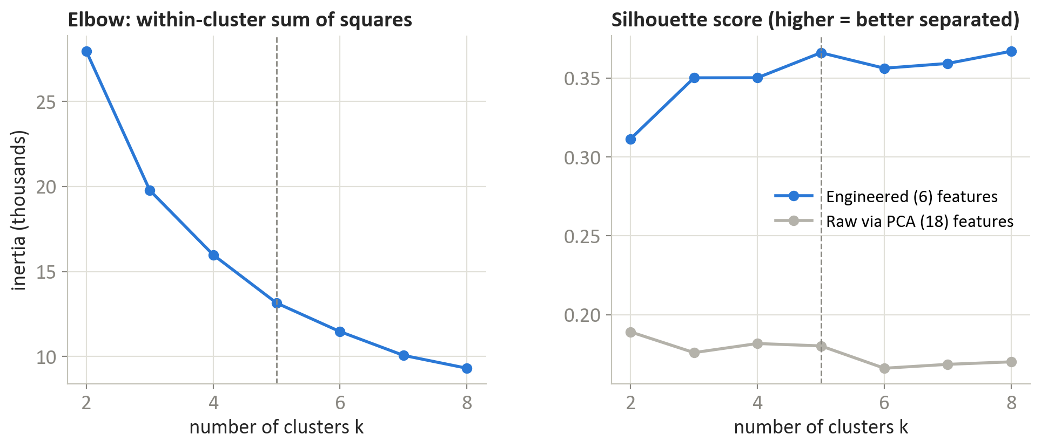
Figure 2 - Elbow curve and silhouette scores for K-means with 2 to 8 clusters. The engineered features separate customers about twice as well as the raw flags at every k.
The silhouette score of the engineered features plateaus at about 0.35-0.37 from k = 3; k = 5 is the smallest number of clusters within 0.005 of the best score (0.366) and sits where the elbow flattens. More clusters mostly split existing segments without separating customers better, so 5 segments were used for every algorithm.

4.3 Five variations compared
Variation | Silhouette | Davies-Bouldin | Calinski-Harabasz | Smallest segment | Stability (ARI) | Churn range
K-means, raw features via PCA | 0.180 | 1.79 | 1,235 | 15.0% | 0.99 | 5%-58%
K-means, engineered features | 0.366 | 1.06 | 3,896 | 13.5% | 0.99 | 1%-56%
Hierarchical (Ward), engineered features | 0.338 | 1.11 | 3,449 | 14.2% | 0.79 | 2%-55%
Gaussian mixture, engineered features | 0.285 | 1.25 | 3,006 | 13.7% | 0.95 | 5%-55%
DBSCAN, engineered features (19 clusters, 1.3% noise) | 0.299 | 1.42 | 1,831 | 0.4% | - | 1%-58%

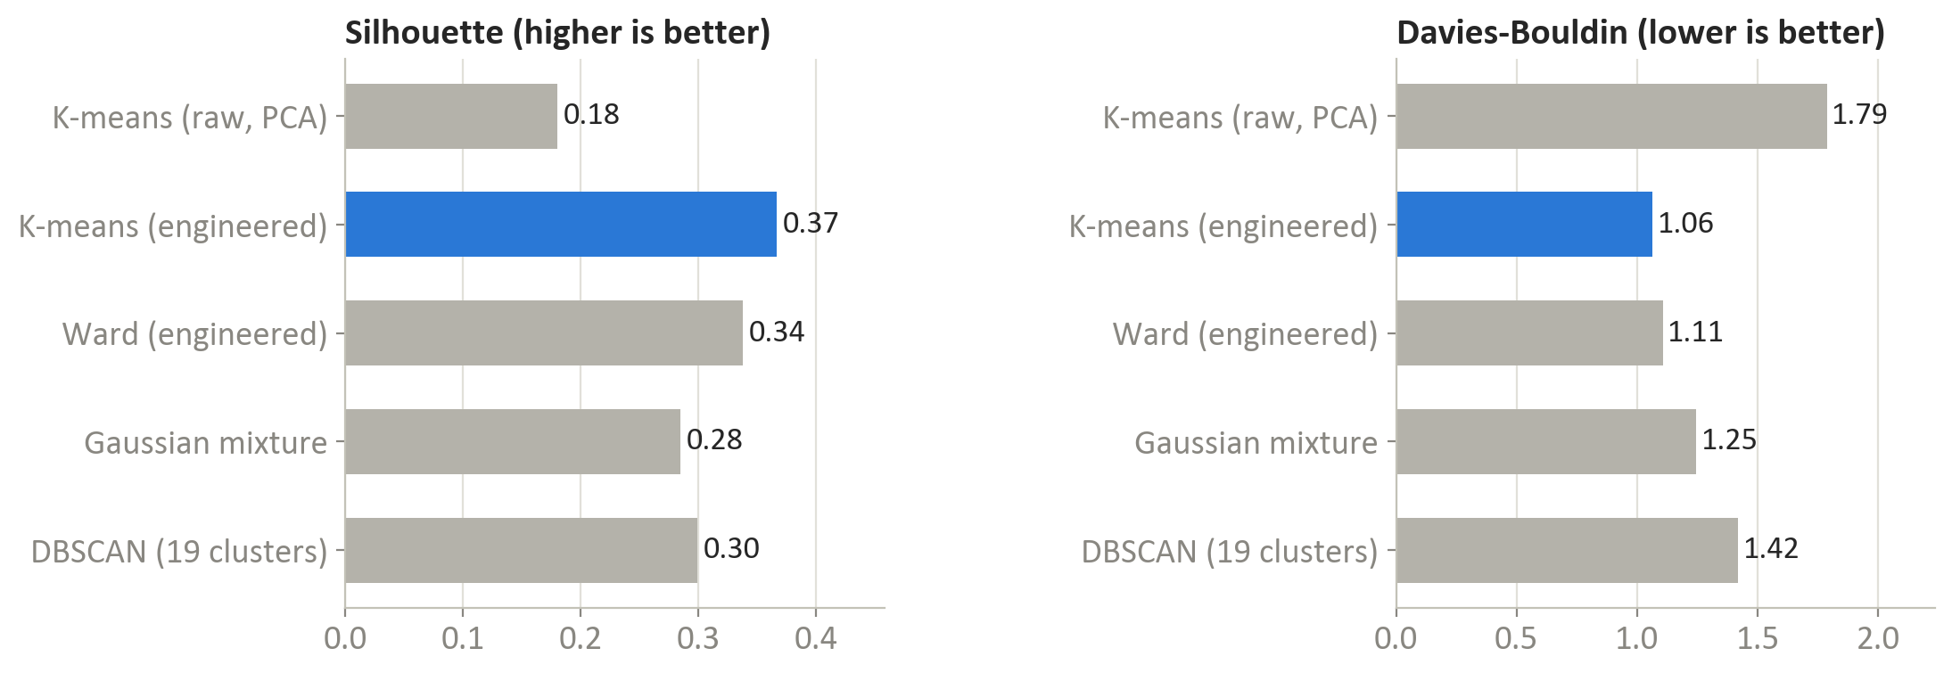
Figure 3 - Silhouette and Davies-Bouldin scores of the five variations; the recommended variation is highlighted.
- K-means on the raw flags (via PCA) separates customers poorly (silhouette 0.18): many binary columns add noise to the distances.
- K-means on the engineered features is best on all three quality scores, has balanced segments (smallest 14%) and is almost perfectly stable (0.99).
- Hierarchical clustering (Ward) finds a similar structure (silhouette 0.34) and its dendrogram confirms 5 natural groups, but it is less stable (0.79) and cannot assign new customers without refitting.
- Gaussian mixture gives soft memberships but overlapping, less separated segments (silhouette 0.28).
- DBSCAN breaks the customers into 19 density pockets, the smallest holding 0.4% of customers: the features take few distinct values, so density-based clusters follow artefacts rather than segments.
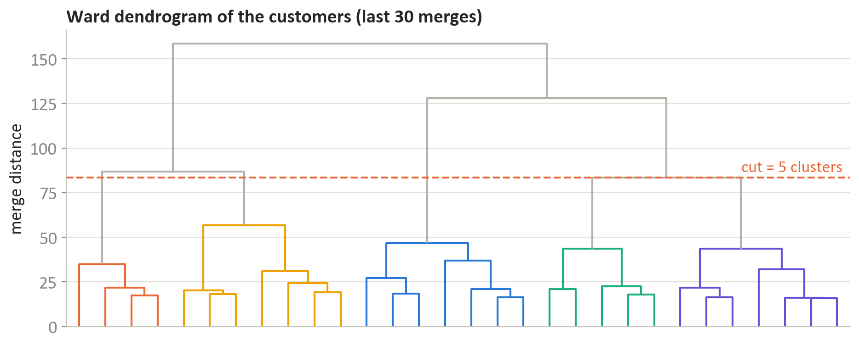
Figure 4 - Ward dendrogram (last 30 merges). The long vertical lines above the cut show that 5 groups are well separated; merging further would join very different customers.

5. Final model recommendation
Recommended: K-means with k = 5 on the six engineered behavioural features. It best fits the objective of a stable, explainable and actionable segmentation:
- Best separation: silhouette 0.37, Davies-Bouldin 1.06 and Calinski-Harabasz 3,896 - the best values of the five variations.
- Stable: refitting on random 80% samples reproduces the same segments (adjusted Rand index 0.99), so the segments can be tracked over time.
- Interpretable: each segment is described by its average customer on six business-friendly features, which makes naming and communicating the segments easy.
- Actionable and deployable: segment churn rates range from 1% to 56%, and new customers are assigned to the nearest centroid with a single calculation.

6. Key findings and insights
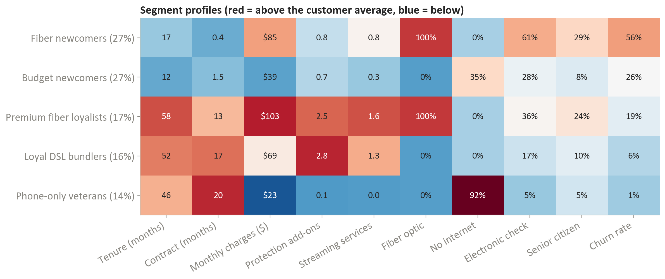
Figure 5 - Average customer of each segment (segment share of customers in brackets). Colours compare each value with the customer average; churn rate and billing were not used to build the segments.
Segment | Customers | Churn | Revenue | Lost revenue | Recommended action
Fiber newcomers | 27% | 56% | 35% | 65% | Priority retention: move them to 12- or 24-month contracts early, bundle tech support and security into fiber plans, switch electronic-check payers to autopay, and fix fiber quality issues.
Budget newcomers | 27% | 26% | 16% | 14% | Low-cost onboarding: a first-year welcome journey, entry-level bundles and digital nudges towards longer contracts.
Premium fiber loyalists | 17% | 19% | 27% | 17% | Protect the most valuable base: loyalty rewards, proactive service-quality monitoring and contract renewals before expiry.
Loyal DSL bundlers | 16% | 6% | 17% | 3% | Grow carefully: fiber upgrade offers that keep their protection bundle and contract; avoid disrupting a loyal group.
Phone-only veterans | 14% | 1% | 5% | 0% | Low touch: cross-sell internet to a stable base; little retention spend is needed.

Revenue = share of all monthly charges; Lost revenue = share of the monthly charges of customers who churned.
- Fiber newcomers drive the churn problem: 27% of customers, 56% churn, 65% of lost revenue. They sit on the low-commitment, high-spend side of the segment map (Figure 6). Retention money spent anywhere else has far less impact.
- Commitment is the dividing line: the two month-to-month newcomer segments churn at 26% and 56%, the three committed, long-tenure segments at 1%-19% - even the highest-paying one - which supports contract-conversion offers as the main lever.
- Bundles signal loyalty: Loyal DSL bundlers average 2.8 protection add-ons and churn at 6%, against 0.8 add-ons for Fiber newcomers.
- Segments line up with the churn drivers found in the classification project (contract, tenure, fiber, add-ons, electronic check), which gives the business one consistent story across both analyses.
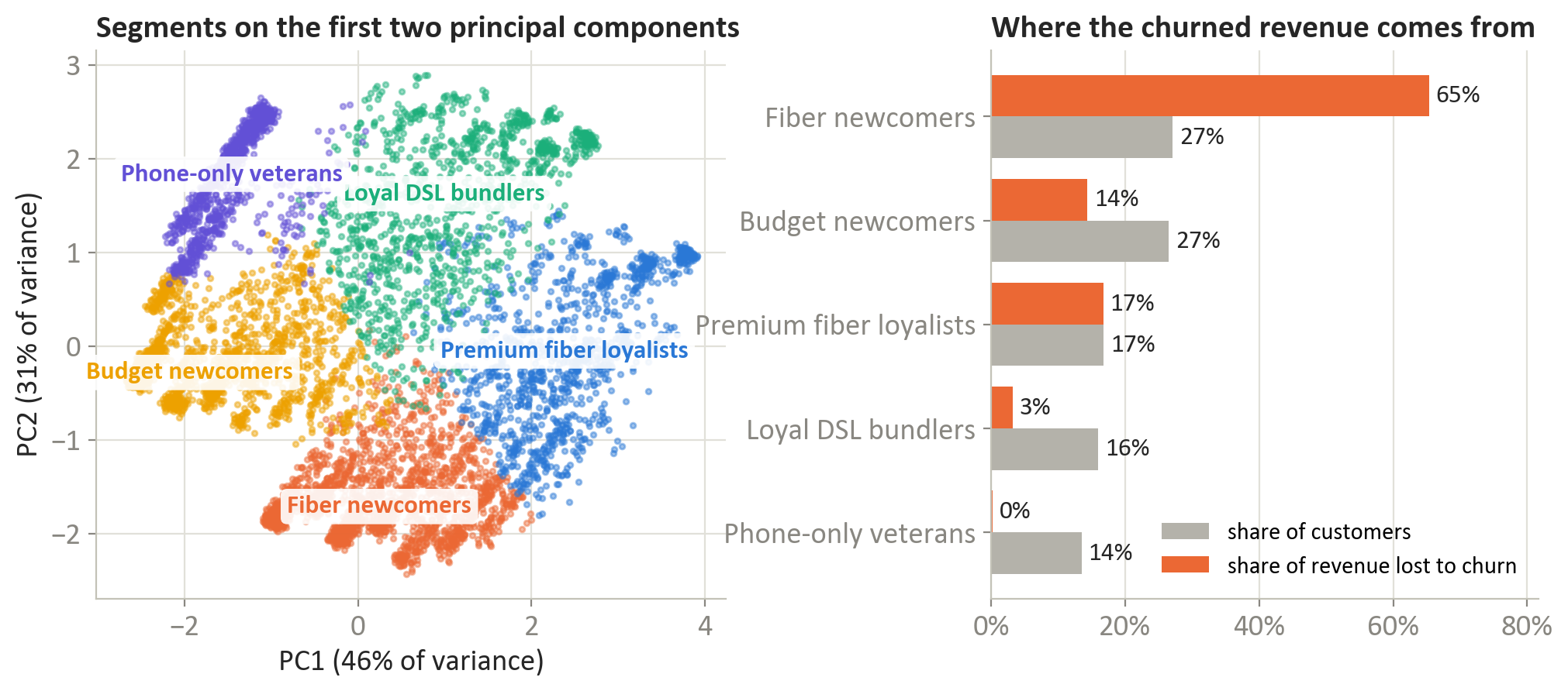
Figure 6 - The segments on the first two principal components (left) and each segment's share of customers versus its share of the revenue lost to churn (right).

7. Do segment-specific churn models beat one global model?
As an optional check, the churn model from the classification project (L2 logistic regression) was trained three ways on the same 80/20 split, with the segmentation refitted on the training customers only:
Approach | Test ROC AUC | 95% interval
One global model | 0.843 | 0.821-0.865
Separate model per segment | 0.843 | 0.821-0.865
Global model + segment feature | 0.844 | 0.821-0.866

Separate models per segment perform the same as one global model (difference in ROC AUC between -0.006 to +0.006, 95% bootstrap interval) and adding the segment as a feature changes almost nothing. The segments are built from the same information the global model already uses, and splitting the data leaves less to train on in each segment. The conclusion: use the segments for strategy and targeting, and keep a single, simpler global model for individual churn scores.

8. Limitations of the model
- Moderate separation: a silhouette of 0.37 means segments touch at their borders; customers near a boundary could reasonably belong to either side, so assignments should be reviewed rather than treated as exact.
- K-means assumptions: it favours round clusters of similar spread and needs k chosen in advance; segments with other shapes are approximated.
- Feature choices drive the result: the six engineered features reflect a business view of behaviour; a different selection (for example usage data) would produce different segments.
- A snapshot of sample data: 7,043 fictional customers at one point in time; segments must be validated on real, current data and their movement over time is unknown.
- Descriptive, not causal: segments show where churn concentrates, not what will reduce it; actions must be tested before scaling.

9. Next steps
- Add data: usage trends, customer-care contacts, network quality and survey scores, to explain why Fiber newcomers leave and to sharpen the segment borders.
- Refine the features and model: test K-prototypes or Gower-distance clustering for mixed categorical data, and Gaussian mixture memberships to flag customers between segments.
- Track segments over time: re-score customers monthly, monitor migration between segments (for example newcomers becoming loyalists) and alert on drift.
- Test the playbooks: run controlled experiments of the recommended action for each segment and measure churn and revenue against a control group.
- Combine with prediction: use the global churn score inside each segment to rank customers for outreach, and survival analysis to time interventions.

Appendix: method and reproducibility
Variation | Settings
K-means, raw features via PCA | 18 standardised features, 10 principal components, k = 5, 10 initialisations
K-means, engineered features | 6 standardised features, k = 5, 10 initialisations
Hierarchical (Ward) | Ward linkage on the 6 standardised features, cut at 5 clusters
Gaussian mixture | 5 components, full covariance, 3 initialisations
DBSCAN | eps = 0.80 (95th percentile of the 12-nearest-neighbour distance), min_samples = 12

- Data: IBM Telco Customer Churn sample (github.com/IBM/telco-customer-churn-on-icp4d), stored in Final Project/data.
- Analysis: Final Project/Unsupervised ML - Customer Segmentation.ipynb - every table and figure in this report is produced there and saved to the results and figures folders.
- Environment: Python 3.11, pandas 2.2, scikit-learn 1.5, SciPy 1.13, matplotlib 3.9; random seed 123.
- This report: Final Project/source/build_report.py builds it from the saved results; export_pdf.ps1 updates the contents and saves the PDF with Microsoft Word.

